AWS Essentials Batch 1

Day 3 Assignment

**Project 1:** Deploying a web server in Windows instance

**Public IP for windows :** 3.20.57.229

Create a windows instance using AMI: Windows 2019 base

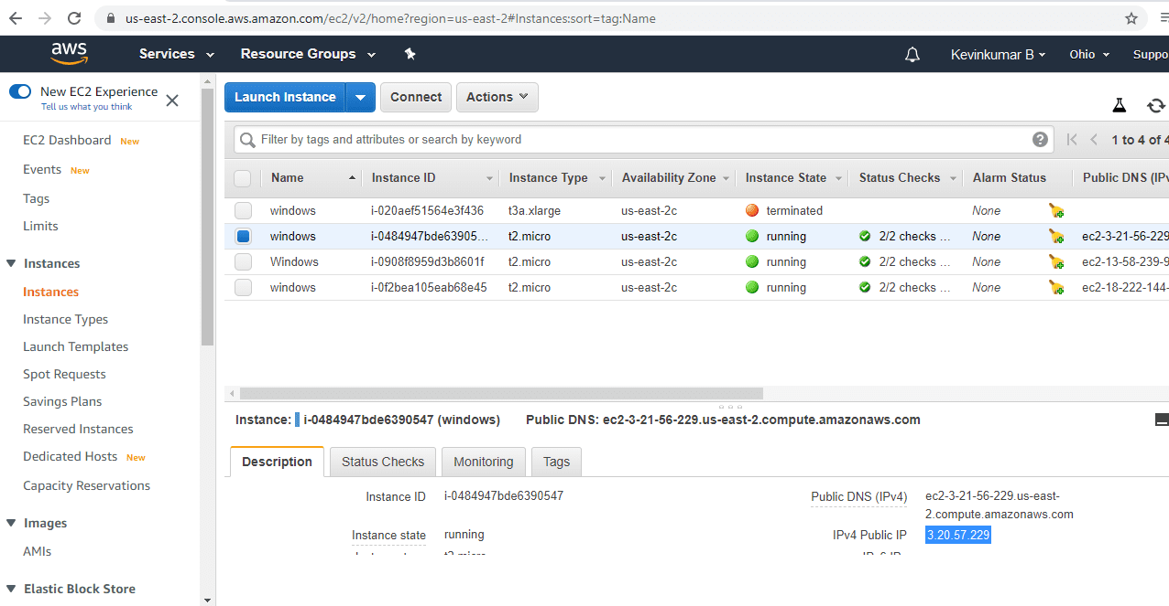

Verify successful installation of IIS Web Server:

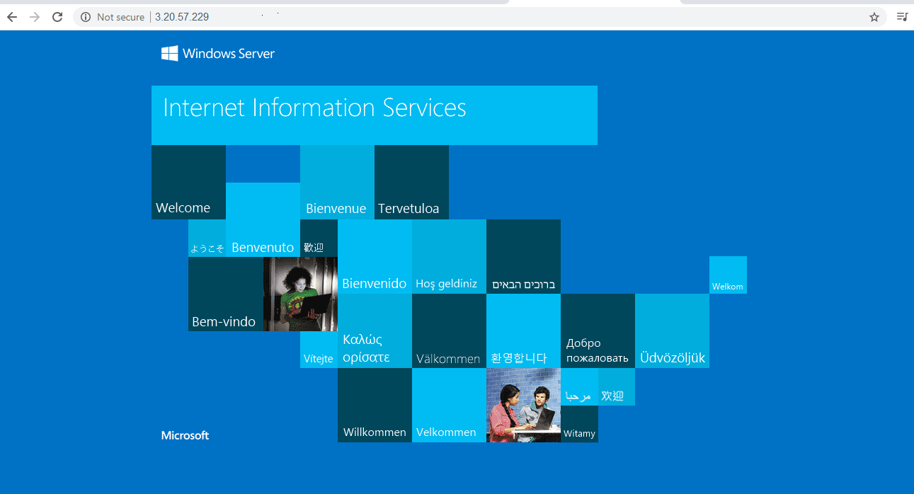

**Project 2:** Deploying a web server in Ubuntu instance

**Public IP for Ubuntu Instance :** 3.14.187.12

Create a windows instance using AMI: Ubuntu Server :

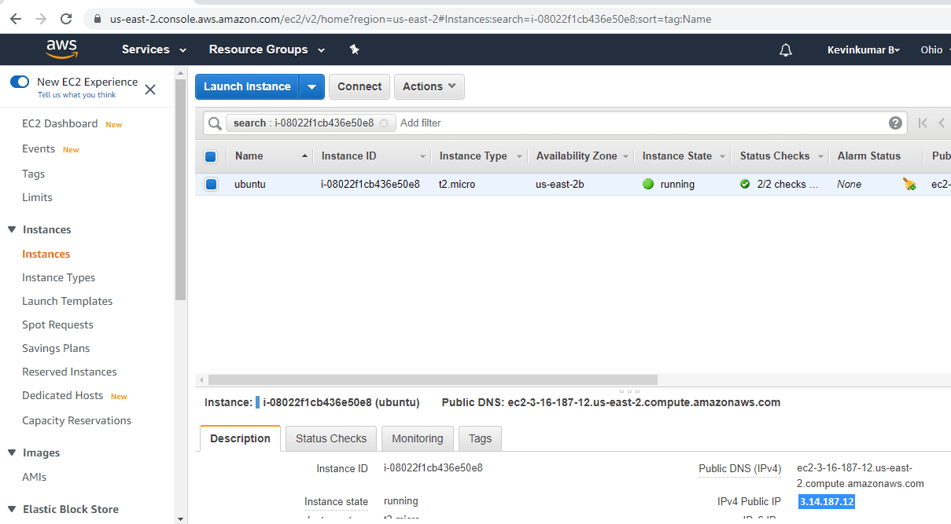

Install ngnix web server using bash

* sudo apt-get -y update
* sudo apt-get -y install nginx

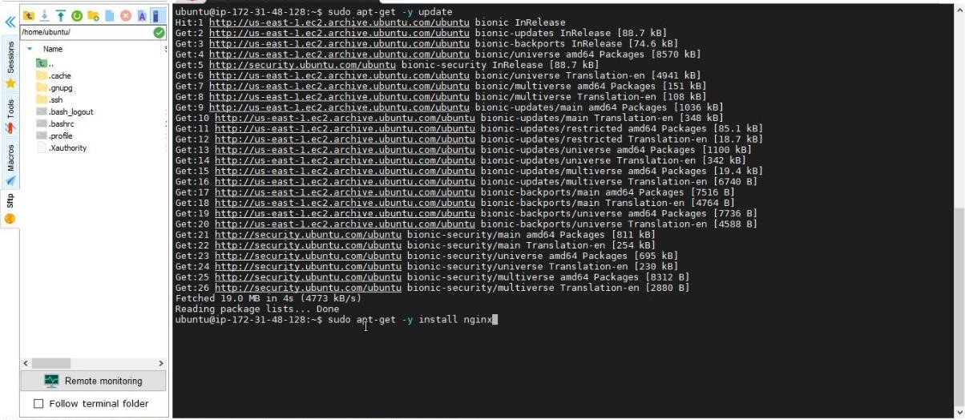

Verify successful installation of ngnix :

